COVID Vaccination and Booster Information
To find out the latest, visit kp.org. To find the latest appointment information visit:
https://healthy.kaiserpermanente.org/hawaii/health-wellness/coronavirus-information/vaccine-appointments

Kaiser Permanente

COVID-19 Vaccination Sites (as of 1/7/22)

Available by appointment only at the following Kaiser Permanente facilities.

Boosters also available by appointment for eligible people.

Parents: Please schedule an appointment for your child online at kp.org/evisits.

Pre-vaccination questionnaire: Please print pre-vaccination questionnaire and bring it to your appointment. If you are not able to print the document, it will be available at your appointment.

Vaccination card: Please bring your vaccination card for your second dose or booster.

Cancellations: To cancel, log in to your our kp.org account and select “Appointments.”

Please cancel your appointment with Kaiser Permanente if you’re scheduled at another health care provider or vaccination center.

Having trouble making an appointment online? Please call 808-432-2000, Monday - Friday,
8 a.m. - 5 p.m. Vaccines are subject to changes based on supply.
OAHU
Monday - Friday, 8:30 a.m.- 4:30 p.m.
(closed noon - 1 p.m.).

- Hawaii Kai Clinic
- Honolulu Medical Office
- Kailua Clinic
- Koolau Medical Office
- Mapunapuna Medical Office
- Moanalua Medical Center
- West Oahu Medical Office
- Waipio Medical Office

MAUI
Maui Lani Medical Office: Tuesday-Friday, 8:30 a.m. to 4:30 p.m. (closed noon to 1 p.m.)
Saturday, 8:30 a.m. to 2:30 p.m.

If you’re already registered on kp.org, you can sign in to make an appointment.

Get your flu shot
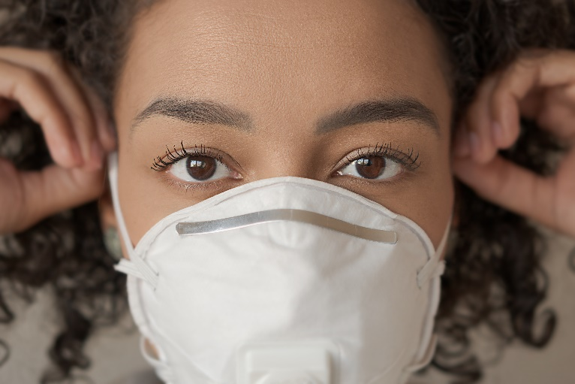
You can have COVID-19 and flu at the same time. Get your COVID-19 vaccine and annual flu shot now to protect yourself and your family. Walk in Monday to Friday, 8:30 a.m. to noon and 1 to 4:30 p.m. at Hawaii Kai, Honolulu, Kailua, Koolau, Mapunapuna, Moanalua, Waipio, West Oahu, Wailuku, Lahaina, Hilo, Kona, Waimea and Lihue. No appointment needed! Our flu shot clinics are open for adults and children 6 months or older. For everyone’s safety, please wear a mask when you visit our flu shot clinics. You also can get a flu shot at no additional cost from some retail pharmacies now through March 31, 2022. To find out more, visit kp.org/flu.
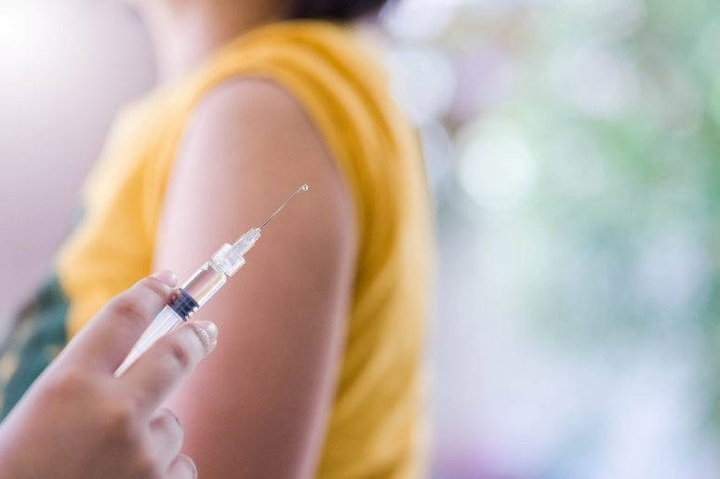
You can get your COVID-19 vaccine or booster at most locations. Please make an appointment for COVID-19 vaccine. Visit kp.org/covidvaccine. If you cannot make your appointment online, call 808-432-2000 on Oahu. On Maui, call 808-243-6000. TTY 711.
FREQUENTLY ASKED QUESTIONS
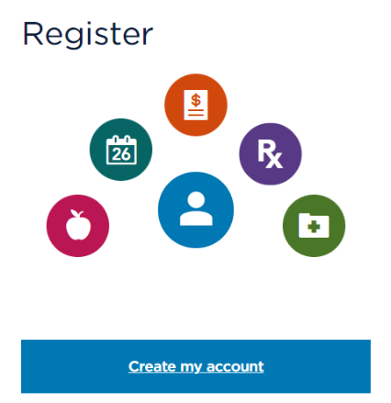
What’s the best way to communicate with my PCP?

- For non-emergent concerns, log into your KP.org account. https://healthy.kaiserpermanente.org/hawaii/register.

- How do I make an appointment with a doctor?

- Book online at kp.org/appointments 24/7.
- During clinic hours, call a clinic.
- After clinic hours, call After-Hours Advice Line.
- On Oahu call: 1-808-432-2000.
- On Neighbor Islands: 1-800-243-6000 (toll free).
- Or 711 TTY for hearing/speech impaired.

- How do I get help with my medication refills?
This Photo by Unknown Author is licensed under CC BY-ND
Fill and refill medication at kp.org/pharmacycenter
Order refills by phone, 24 hours a day, 7 days a week 808-643-7979 (statewide)
TTY 711 (toll free)

- How do I get help with transportation to my doctor appointments?

If you need help to get to your appointment but are unable to get transportation, a Member Care Services Associate (MCSA) may be able to assist you if it is medically needed. Please call at least one week before your scheduled appointment.

Oahu
Oahu Clinics call 808-432-5330
Maui
Maui Clinics call 808-243-6613

